Ideation Phase
Brainstorm & Idea Prioritization

Date | 25-09-2026
Team ID | SWTID-2026-2919
Project Name | AI FitTrack
Maximum Marks | 4 Marks

Step-1: Team Gathering, Collaboration and Select the Problem Statement
Problem Statement
Many people struggle to maintain a consistent fitness routine because they do not have personalized workout guidance or an easy way to track their daily fitness activities. Existing fitness applications may provide general workout plans, but they do not always provide simple, personalized recommendations based on the user's age, fitness goal, and experience level.
Selected Problem
Develop an AI-powered fitness tracking system that allows users to record workouts, track fitness progress, and receive personalized workout recommendations and fitness insights using Artificial Intelligence.
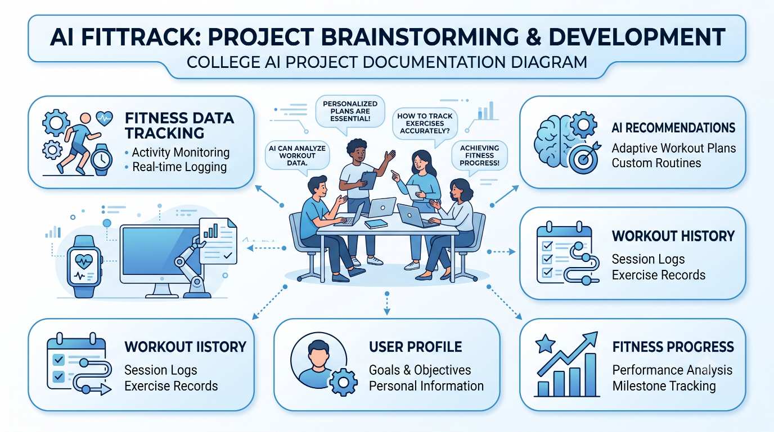

Step-2: Brainstorm, Idea Listing and Grouping
During the brainstorming session, the team generated several ideas and grouped them into major categories based on their purpose and importance.
Fitness Tracking
- Workout logging
- Workout history
- Workout duration tracking
- Calories burned tracking
- Workout categories
- Search workout records
AI Features
- Personalized workout recommendations
- Fitness progress insights
- Goal-based suggestions
- Experience-level recommendations
User Management
- User registration
- Secure login
- JWT authentication
- User profile
Technology
- Node.js
- Express.js
- MongoDB
- Google Gemini AI
- REST API
Future Ideas
- Diet recommendations
- Progress charts
- Exercise reminders
- Mobile application
- Wearable device integration
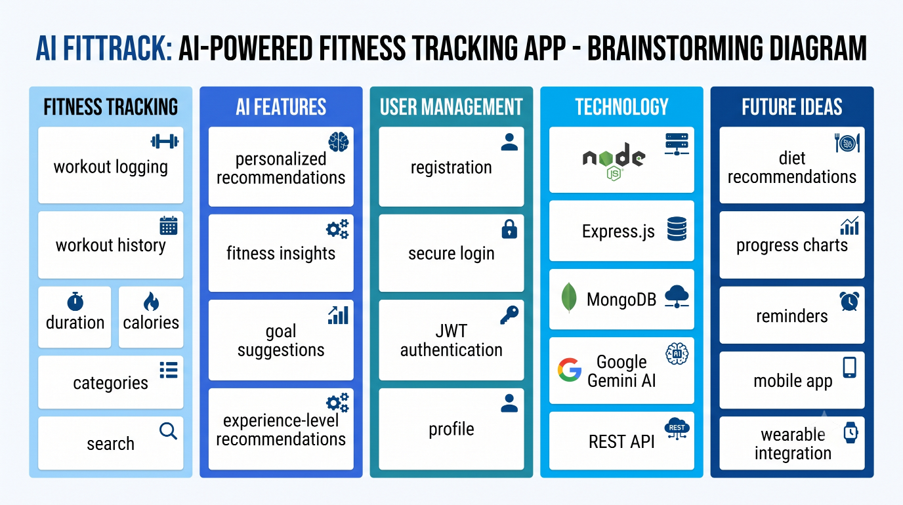

Step-3: Idea Prioritization
The brainstormed ideas were evaluated based on their importance, usefulness to users, feasibility, and relevance to the main problem. The most important features were selected for the first version of AI FitTrack.
Idea | Priority | Reason
Workout Tracking | High | Core function of the application
AI Workout Recommendation | High | Provides personalized guidance
Fitness Insights | High | Helps users understand their progress
User Authentication | High | Protects user information
Workout Search | Medium | Makes workout history easier to access
Progress Charts | Medium | Helps visualize improvement
Exercise Reminders | Medium | Helps maintain workout consistency
Diet Recommendation | Low | Can be added as a future enhancement
Wearable Integration | Low | Requires additional hardware/API integration
Final Prioritized Concept
AI FitTrack was selected as the final idea because it combines fitness tracking with AI-based personalized recommendations. The system focuses on essential features that can be developed and demonstrated effectively, while additional features can be added in future versions.
